

**GE Healthcare**

**Information Technology & Process Excellence**  
Understanding of Smart Dispatch Tool application

|  | **Name** | **Role Title** | **Department** |
| --- | --- | --- | --- |
| **Author(s):** | Sathyaraj R | Business Analyst | GEHC |
| **Reviewer(s):** | Saraswathi N | Project Manager | GEHC |
|  |  |  |  |
| **Approver(s):** |  |  |  |

**Revision History**

A record of changes made to this document by the project team.

|  |  |  |  |  |  |
| --- | --- | --- | --- | --- | --- |
| Revision | Date | Author | Change Control | Change Reference | Reason for Change |
| 1 | 05-Dec-2016 | Sathyaraj R |  | Entire document | Initial Release |

Contents

This document contains the following sections:

1 Purpose 5

2 Scope 5

3 Team and their Roles 5

4 Understanding 6

4.1 Smart Dispatch Tool (SDT) 6

4.1.1 Process Flow 6

4.2 Support Activities 10

# 1 Purpose

The purpose of this document is to describe the understanding of Capgemini team on the SDT project through the knowledge transfer process from Tech Mahindra team. It outlines the business understanding along with the tasks and activities involved in the project.

# 2 Scope

Not Applicable

# 3 Team and their Roles

Table ‑: Team and their roles

| Team | Role |
| --- | --- |
| Capgemini Team | * Saraswathi N – Project Manager * Sathyaraj R – Business Analyst * Suvarna D – Scrum Master * Syed Farhan Husain – Senior Developer * Hita Soni – Senior Developer * Prajna M – Senior Developer * Tejashree B – Senior Developer * Ebaad C – Senior Developer * Jayesh Soni – Developer * Deepak V - Developer |
| Transition Team | * Krishnachaitanya P – Transition Manager |
| Tech Mahindra Team | * Martand T * Debashis M * Joy C * RajeshBabu K * Prosenjit G * Srinivas D |
| GEHC Team | * Chandramohan G – Sr. Technical Product Manager * Rohit H – Sr. Technical Project Manager |

# Understanding

## 4.1 Smart Dispatch Tool (SDT)

Smart Dispatch Tool(SDT) application helps to optimize the assigning and scheduling process of Field Service Engineers (FSE) visit to the customer locations. It optimizes the process based on certain criterias such as,

* Field Service Engineers
  + Skillset
  + Availability
  + Proximity to the location
* Service Request
  + Priority

It interfaces with few 3rd party components:

1. Applications in GE network are upstream app i.e. master system. (e.g. SDT )
2. Applications out of GE network are downstream app.(e.g. SIEBEL, Click )

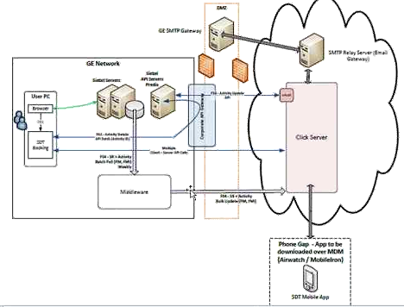

### 4.1.1 Process Flow

An End User calls the customer help desk for an appointment for maintenance activity/installation. Customer care representative logs a request in the siebel system.

1. Through Informatica(Middleware), bulk appointment booking is done (Need to be discussed with middleware team)
   1. There are chances that few records may get failed in bulk load
   2. Modifications may require in any appointments

For the above reasons, manual booking is done in SDT application.

1. Once he/she fills up the fields, clicks on “SDT Book Appointment”. SDT booking is launched after this process.

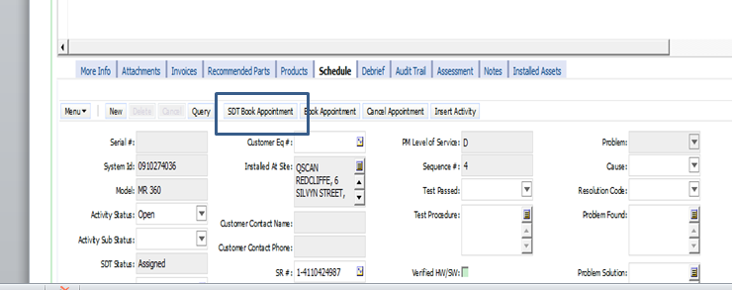

Post this, one can access the SDT application for that particular request.

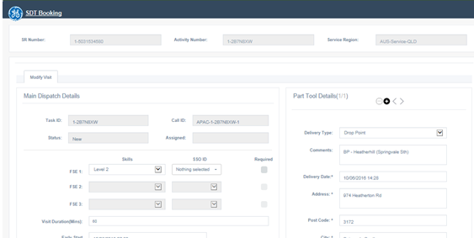

This will be pre-populated with the details from siebel.

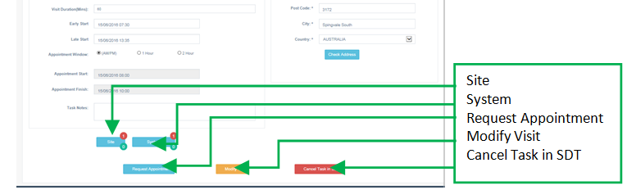

Here,

* Site - Indicates the number of tasks already booked onsite
* System – Indicates if your system or how many other system task appointments has been created onsite
* Request Appointment – To request and show available slots in the next page
* Modify Visit – Modify a current task and request another appointment
* Cancel Task in SDT – Cancel a task only if it meets Cancellation exceptions

A FSE may require parts to perform the installation or maintenance activity. For that, part details can be added to the booking request in the section shown below.

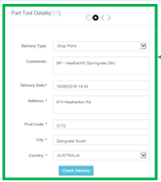

You can add/delete the parts by using “+” or “-“ signs.

Extended slots: In Modify visit window, where user tries to modify the visit time, user have the option to click on **Request Extended Slots** button to extend the visit timings.

Time Zones: This is based on the timezone which is imported from Sieble depending upon the location for which the request is created.

One can view the details in the ClickSoftware panel as shown below.

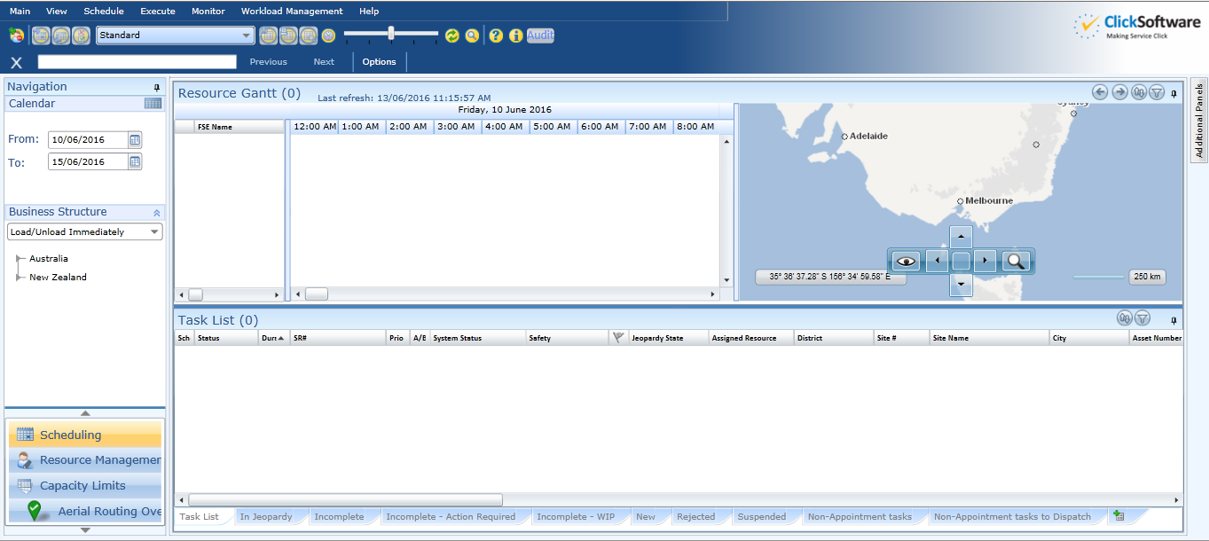

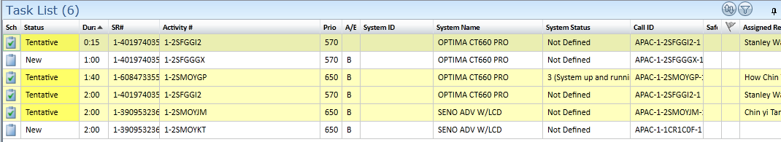

One can view the job type as well in the “Job Type” field as shown below.

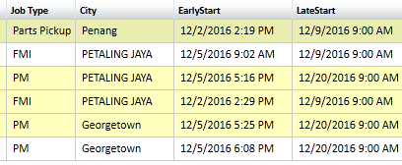

Call ID & Task ID: Call ID is a unique alphanumeric code for a specific task. It is also called as a work order ID and Resource and time dependencies are defined on the same Call ID. The last digit of the Call ID signifies number of jobs in a particular task.

Task ID is a unique numeric code in Click software for differentiating multiple jobs under a same Call ID. Task ID is exported to click software through SDT application

Early Start & Late Start: Early start and late start date is set in SDT application for allotment of appointment time range. These values are set based on two factors firstly specific business logic and secondly SMA Jobs which relies on Job Types.

Dependencies: It is defined as the need of visiting more than one site deliveries specified in the same job. To create dependency for a job we need to revoke any dependencies (dependencies for a particular job can be viewed in Site dependency page).

There are two types of dependencies namely Potential dependency and Linked Same Site dependency.

Potential Dependency: It is denoted by the red bubble on the Site Placeholder and determines the number of potential dependencies in the same Job (These activities are yet to be performed), It is available under the list of activities in the click software.

Linked same site dependency: It is denoted in the green bubble in the Site Placeholder and determines the number of launched jobs.

Note: There is also a same resource dependency for visiting same site by a same engineer and a same date dependency for visiting sites on the same date for the same engineer. In case of any redundancy in booking appointments in Click software the aforementioned redundancy is resolved/optimized by Click Software.

System Dependency: A Sysytem is defined as a GE Healthcare product in the scppe of System dependency.Similar to Site dependency we have potential system dependency and linked same syatem dependency.

Potential same system dependency: It is used incase of dependency for a particular system. The potential same system page logs all the dependencies along with the Job’s rating , its task and call ID and the Job’s status.The serial number is unique for every GE healthcare product along with the Call ID. Multiple task iDs can be in the purview of a single call id. The Job ststus before getting assigned to a field engineer is ‘Tentative’ and afetr assigning the Job status becomes as ‘Assigned’

Job rating in Same site and same system dependencies: Rating is defined in SDT application, It is calculated on the basa of various factors like The quality of main job, The quality of dependent job, The skillset of the visiting field engineer etc. The call centre representative tries to achive highest rating possible. Rating suggests the yield to the parant company in terms of optimization and also determines the Modality (i.e the quality) of the Product.

Installation Job View in SDT: There are a number of jobs in SDT amongst which is a Multiday Task. An example of a Multiday task is a Product Installation task, this task may include the installation of entire product , movement of a product from one location to other and iinstallation of adhoc peripherals for the GE Healthcare products. For these types of jobs there is no need for early start and late start dates. The task duration is estimated beforehand and can be set in the SDT application prior to the launch of the task. The ‘Select hours’ functionality in SDT has two drop down menus first of which has Days in steps of 8 hours(Normal work hours) and the second drop down has hours from 1 hour to 7 hours. For example if the call center representative wants to schedule the job for 2 and a half days then hhe/she should select 16 hours from the first dropdown menu which indicates two working days and 4 hours from the second drpdown menu which indicates the number for additional hours for the half day.

## Support Activities

There are various support related activities such as,

* + Issues related to SIEBEL
  + Issues related to SDT
  + Issues related to Click

Different Status of task: From service now we can get the Status description

* + New
  + Active
  + Awaiting Problem
  + Awaiting User Info
  + Awaiting Incidence
  + Resolved
  + Resolved Awaiting Response
  + Closed

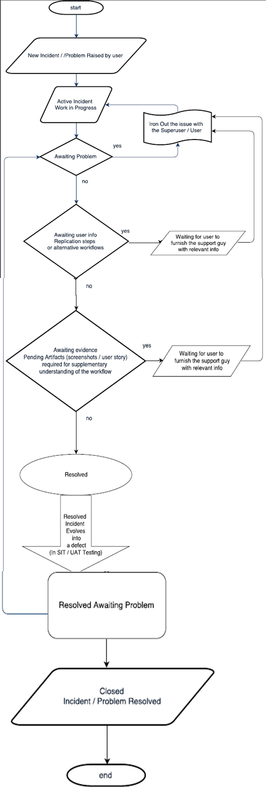

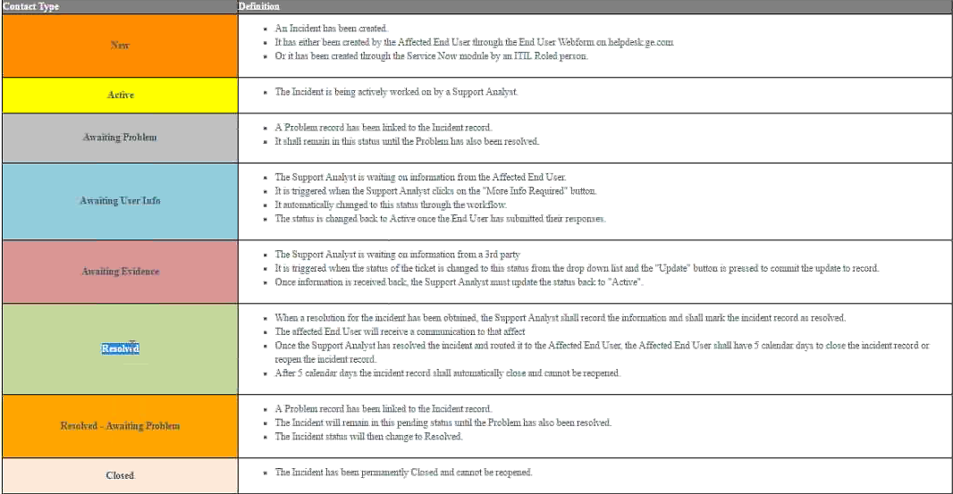

* Support Activity for SDT application and all the downstream system is accomplished via the Service Now Application.
* Issues related with Siebel, Click and SDT will arrive for resolution to our support team, from these the issues in relation with Siebel and click will be reassigned to the Respective third party support teams.

The Following are the status definitions for the incident life cycle in Service Now:-

1. **NEW**: The fresh incident raised by the User/Superuser
2. **ACTIVE**: Work in Progress phase.
3. **AWAITING PROBLEM**: Additional issue linked with the incident.
4. **AWAITING USER INFO**: Additional alternate flows and replication steps required in order to resolve the incident (Due to description deficiency)
5. **AWAITING EVIDENCE**: Additional screenshots and/or replication steps required to reach the resolution of the incident.
6. **RESOLVED**: The incident is resolved and fixed by the support team waiting for the sign-off from the SDT user.
7. **RESOLVED AWAITING PROBLEM**: Wait period for user response , whether the incident is fixed according to the user specifications.
8. **CLOSED**: Incident is closed.

Points to be remembered:

* The SLA(Service level agreement) of an incident is determined by the Urgency and the Impact of the issue.
* The configuration item in service now refers to the name of project
* The assignment group is the selection of team for incident resolution
* Incase many incidents pertaining a same problem in SDT is raised then we try to solve one of them and others are treated as clones.
* HELP_SDT_APAC_SUPPORT is the default group for resolving issues in scope with the SDT app.
* For incidents under the scope of downstream systems namely Siebel and click software we need to reassign them to the respective third party support teams.
* If the user who has raised the incident fails to respond to the Awaiting user info and awaiting evidence requests then we should escalate the incident and mail them requesting the required details.
* Any communication with the user is logged along with the ‘Customer visible’ and ‘Not customer visible’ comments.
* The envelope icon at the top right hand side corner in service now is used for communication with the user/superuser.
* After resolution of the incident click on the ‘Resolve Incident Button’ at the top right hand side corner in service now, it is imperative to enter the Resolution code and resolution comments for closing an incident.
* Only after accepting the incident will the incident status change from New to Active.
* The ‘Add me to Watch list’ button on the at the top right hand side corner in service now is for keeping a particular incident under our eye.

Risk Management:

The impact of the incident is specified after the impact analysis to the affected user, the impacted module or the system is communicated to the user by means of the RCA comments.